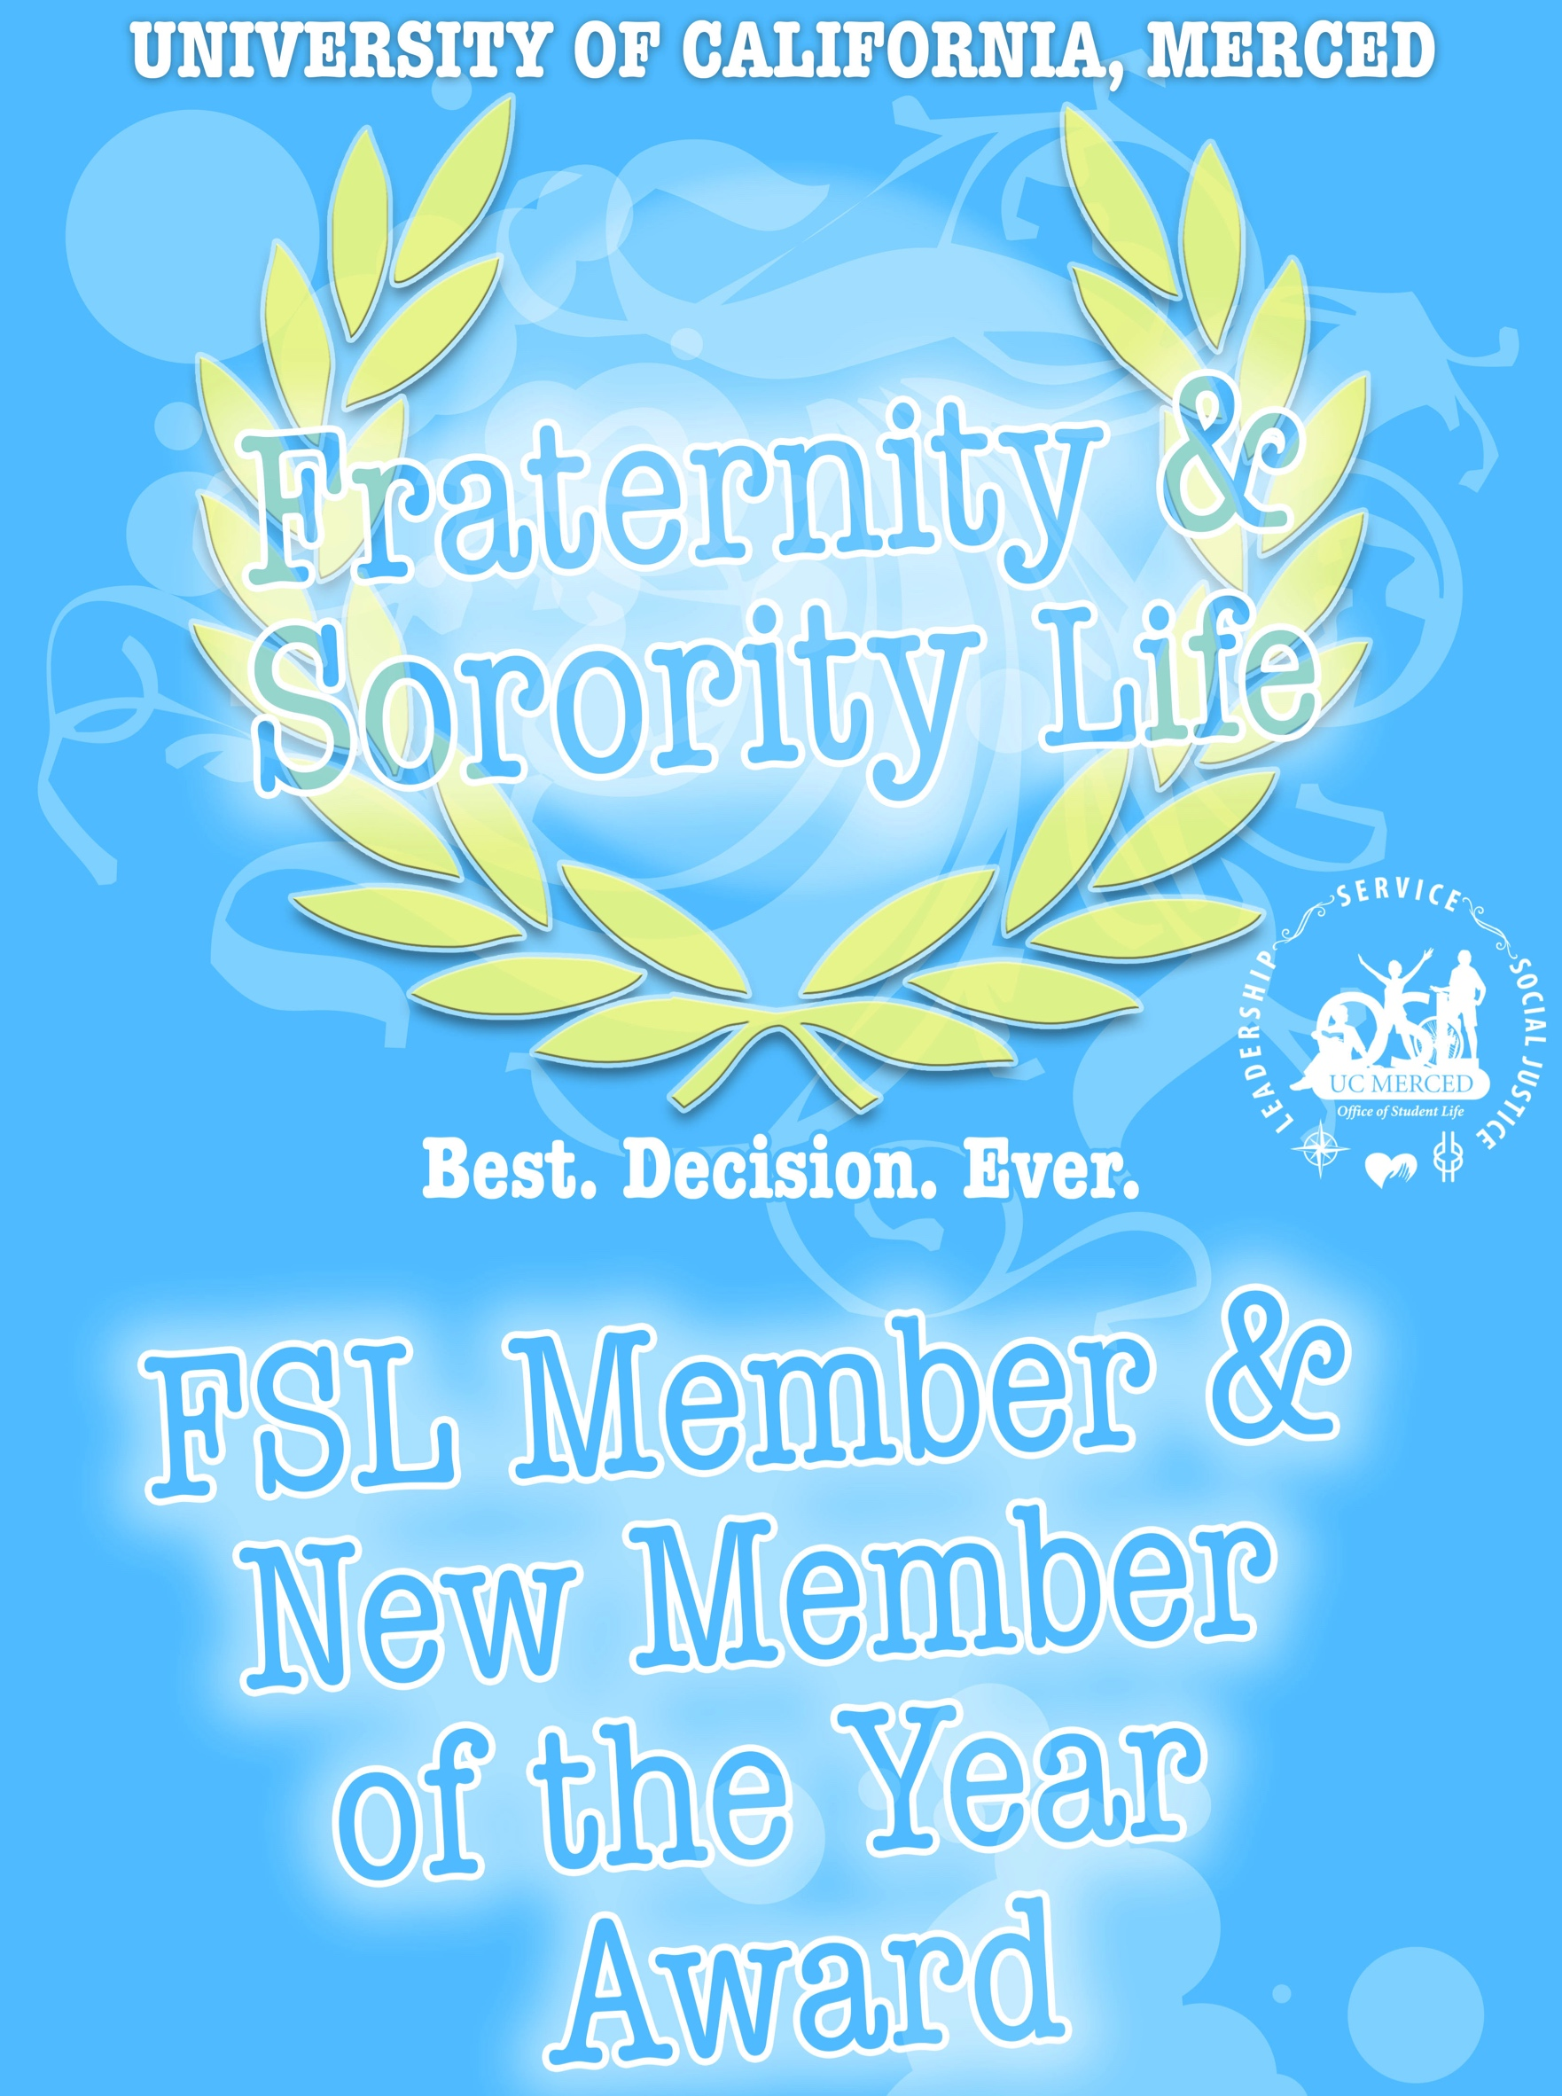
Purpose
The purpose of the Outstanding Member and New Member of the Year Awards is to recognize a student who is a member of a Fraternity and Sorority Life chapter, who has made a significant overall contribution to the University of California, Merced Fraternity and Sorority Life Community through the embodiment of the FSL Values of Scholarship, Leadership, Service, and Friendship.
Timeline
Timeline for 2016:
- This award will performance over the course of an applicants entire involvement at UC Merced.
- Submission form will be made available by: February 8th 2016
- Final Submission DUE by: March 8th 2016 at 11:59pm (no late submissions will be accepted)
- Award Interviews: March 31st – April 6th 2016
- 2016 Student Leadership Awards: April 28th 2016
Method of Evaluation
Outstanding Member and New Member of the Year Award submissions will be reviewed internally by the Fraternity & Sorority Life staff to ensure all applications are complete, and then reviewed and decided on by a committee comprised of the following individuals:

- FSC Chapter Advisor
- PFC Chapter Advisor
- Division of Student Affairs Representative
- FSL Intern
- Coordinator for FSL

Applicants will be evaluated based on meeting the award eligibility requirements, their contributions to the campus and FSL community, their involvement in and outside of FSL organizations, their alignment with the FSL community values, and their interview with the committee.

Award Eligibility
- All answers and supplemental material submitted must be legitimate and factual.
- Applicant must be in good academic and conduct standing with the University, their chapter, and the Fraternity and Sorority Council/Professional Fraternity Council.
- Be currently enrolled in the University.
- Have a 2.5 cumulative GPA or higher with UC Merced. (Note: transfer credits do not count towards this total)
- Be a member of a recognized fraternity or sorority under the umbrella of Fraternity and Sorority Life.
- Been initiated into their respective chapter prior to Fall 2015.
- An applicant cannot win the same award more than once and may not apply for both awards in the same year.
- Eligibility for the following awards specific to initiation date include:
  - Outstanding Member of the Year: Initiated prior to Spring 2015
  - Outstanding New Member of the Year: Initiated during Spring 2015 or Fall 2015

Note: The Chapter of the Year Awards was adapted from the University of Missouri- St. Louis, Fraternity & Sorority Life Member of the Year award.
Award Application
All applicants must submit the following via the online form no later than March 8th 2016 at 11:59pm. All submissions must be in individual PDF documents.
- Cover Letter – This should explain why the student believes they are qualified for this award. This letter should allow the student to elaborate on their contributions to the university, and the community. This should be on no more than two standard pages, 12-point font, and standard margins. Some guiding questions include:
  - How have you positively impacted your chapter, the FSL community, and the campus during your time as a member?
  - How have do you embody the FSL Values: Scholarship, Leadership, Service, and Friendship?
  - Why did you choose to join a fraternity or sorority?
  - In what ways has membership in a fraternity or sorority, provided you support to succeed as a student at UC Merced?
- Resume – Include relevant job, leadership, and academic involvement.
- Signed GPA Release
Interview
Following review of the initial application, selected candidates will be interviewed. This interview will be with the members of the award committee. Interviews will be no more than 30 minutes and will be used to get to know the candidates better. Those that are offered interviews will be contacted directly to schedule a time for the interview.

