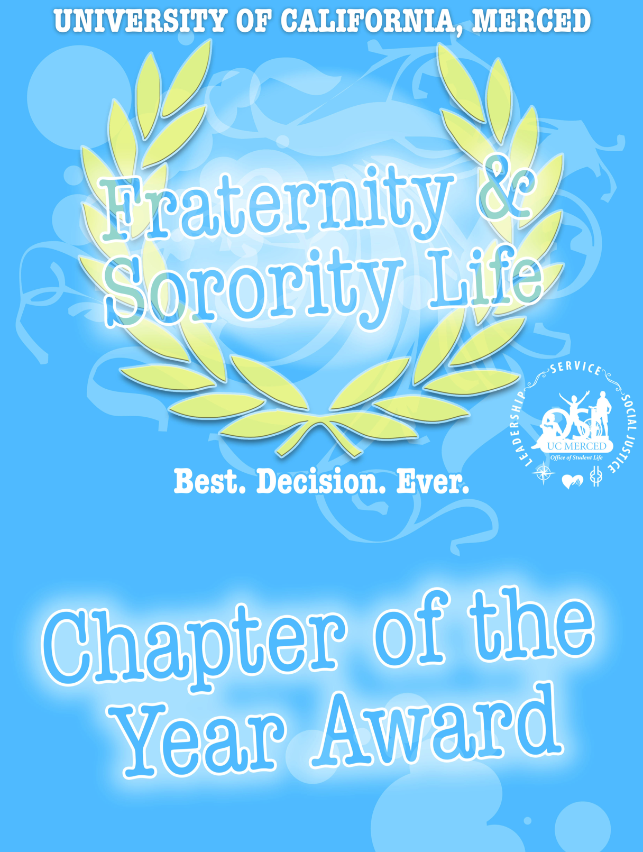
Purpose
The purpose of the Chapter of the Year Award is to:
- Assess Chapter performance based on the four pillars of Fraternity & Sorority Life at University of California, Merced: Scholarship, Leadership, Service, and Friendship
- Promote and uphold the expectations and operational standards of the Fraternity & Sorority Life office
- Provide Chapters with a comprehensive guide of best practices that encourages continuous improvement
- Recognize high-performing Chapters and hold underperforming Chapters accountable
- Ensure that students involved in Fraternity & Sorority Life are receiving a well-rounded fraternal experience

Overview
The Chapter of the Year Award overview:
- All Chapters and colonies affiliated with the University of California, Merced are required to participate.
- The program will review Chapter performance over one (1) calendar year through the submission of narratives, Chapter programs, and other detailed supplemental materials submitted
  - Detailed supplemental materials and/or explanation must be provided to support answers and gain points. This can include, but is not limited to: written programs, policies and procedures, event summaries and photographs, detailed spreadsheets of relevant statistics, and relevant letters of support.
- Submissions are broken down by the four pillars: Scholarship, Leadership, Service, and Friendship
  - Within each pillar are three to four subsections (shown below) composed of 55 total questions.
- Each subsection will be comprised of PRIMARY and SECONDARY YES/NO questions, with further follow up questions to guide your chapter in its explanation.
  - PRIMARY QUESTIONS are considered ‘basic expectations’ and are worth 10 points each
  - SECONDARY QUESTIONS are considered ‘exceeding expectations’ and are worth 5 points each

Pillar 1: Scholarship | Pillar 2: Leadership | Pillar 3: Service | Pillar 4: Friendship
Academic Achievement | Member Development | Chapter Community Service | Brotherhood/Sisterhood
Standards & Accountability | Chapter Management | Chapter Philanthropy | Member Accountability
Scholarship Programming | Risk Management | Community Service Participation | Interfraternal Relations
 | Leadership Programs & Conferences | Philanthropy Participation | University & Community Relations

Timeline
Timeline for 2016:
- The program will review Chapter performance from the 2015 calendar year: Jan 1, 2015 – Dec 31, 2015.
- Submission form will be made available by: February 8th 2016
- Final Submission DUE by: March 8th 2016 at 11:59pm (no late submissions will be accepted)
- Finalists announced to campus: April 7th 2016
- 2016 Student Leadership Awards: April 28th 2016

Method of Evaluation
Chapter of the Year Award submissions will be reviewed internally by the Fraternity & Sorority Life staff, and then reviewed and decided on by a committee comprised of the following individuals:

FSC Chapter of the Year
- FSC President
- FSC EVP for Panhellenic
- FSC EVP for NALFO
- FSC EVP for Fraternities
- FSC Chapter Advisor
- FSL Intern
- Coordinator for FSL (non-voting)
PFC Chapter of the Year
- Two PFC Chapter Presidents
- Two PFC Chapter Advisor
- FSL Intern
- Division of Student Affairs Representative
- Coordinator for FSL (non-voting)

Note: a chapter may not have more than two representatives on their respective award committee.
How points are awarded (points are only gained):
- Internal Evaluation: Fraternity & Sorority Life Staff will award ALL points or NO points to each question based upon the submission material provided (Primary: 10 pts. | Secondary: 5 pts.).
- Committee Evaluation: Evaluators will award points based on their own opinion of the detail and thought given to the material provided for each subsection (Primary: 10 pts. | Secondary: 5 pts.).
- Total Points: Points awarded from FSL staff and volunteer evaluators will be added together for the total score for each subsection. Total points of each subsection will be added together to determine total for each pillar. Total points from each pillar will be added together to determine overall score.
Tips:
- Create a committee tasked to document and record relevant events throughout the year
- Establish Chapter goals that align with the Chapter of the Year questions
- Submit detailed, concise, relevant, and presentable answers to all questions

Award Eligibility
- All answers and supplemental material submitted must be legitimate and factual.
- Chapter must be in good standing with the University and the Fraternity and Sorority Council/Professional Fraternity Council.
- The Chapter with the most points within a given pillar will be awarded a Pillar of Excellence Certificate for that respective pillar.
- Cover letters and overall points earned will be considered for overall Chapter of the Year Awards.

Note: The Chapter of the Year Awards was adapted from the University of Pacific Fraternity and Sorority Life Standards of Excellence Program.
Cover Letter
The purpose of the cover letter is to provide chapters an opportunity to elaborate on some of the challenges and achievements of the year through a narrative. The cover letter can highlights any areas that were included in the application or address areas that may not have been included in the application. The cover letter may not be more than one standard sized page, 12-point font, including the chapter’s letterhead, and must be submitted as a PDF.

Scholarship
Academic Achievement
PRIMARY QUESTIONS:
- Is the cumulative Chapter GPA for active members above a 2.5 for Spring 2015 and Fall 2015? *
- Is the cumulative Chapter GPA for new members above a 2.5 for Spring 2015 and Fall 2015? *
SECONDARY QUESTIONS:
- Is the Chapter’s cumulative GPA above the UC Merced undergraduate GPA for Spring 2015 and Fall 2015? *
- Does the Chapter have members in academic honor societies, on the Dean Honor List*, or have received other notable academic recognitions? Please list the organization, number of individuals on Deans Honor List, and any other notable academic recognition.
Standards and Accountability
PRIMARY QUESTIONS:
- Does the Chapter have a GPA requirement for members to maintain active/good standing? If yes, what is the GPA requirement?
- Does the Chapter have accountability measures in place for underperforming members? If yes, what does this accountability look like? What strategies are used to support these members in succeeding academically?
SECONDARY QUESTIONS:
- Does the Chapter enforce a GPA requirement specific for Chapter Officers? If yes, what is the GPA requirement?
- Does the Chapter have other academic requirements/standards for members? If yes, what are those academic requirements/standards?
Scholarship Programming
PRIMARY QUESTIONS:
- Does the Chapter have an academic focused recognition or incentive program? If yes, please explain.
- Does the Chapter provide opportunities and/or resources to support members in their academics? If yes, please explain.
SECONDARY QUESTIONS:
- Does the Chapter have other programs/events that demonstrate academics as a priority of the organization? If yes, please provide examples/explain.
- Does the Chapter rank scholastically within the top two of their respective council? See grade reports on FSL website.

* Internally Verified by Fraternity and Sorority Life
Leadership
Member Development
PRIMARY QUESTIONS:
- Does the Chapter have a written new member education/development program? If yes, please attach a copy of your new member education/development program.
- Does the Chapter have a member education/development program for active members? If yes, please attach a copy of your active member education/development program.
SECONDARY QUESTIONS:
- Does the Chapter participate in/host programs for members focused on personal/ professional development? If yes, please provide examples/explain.
- Does the Chapter provide each executive members with Membership/Officer Handbooks?
Chapter Management
PRIMARY QUESTIONS:
- Does the Chapter establish and review their goals each semester? If yes, explain how this is done and how it has or has not been effect and how you can make changes in the future.
- Does the Chapter have a functioning committee system? If yes, please list all committees.
SECONDARY QUESTIONS:
- Does the Chapter have an officer transition program? If yes, please elaborate or attach a copy of your officer transition program.
- Does the Chapter include their Advisor(s) in transition and goal setting meetings? If not, why is the advisor not included?
Risk Management
PRIMARY QUESTIONS:
- Does the Chapter educate members on the policies, guidelines, and laws of the local Chapter, inter/national/regional organization, UC Merced, and city of Merced? If yes, when does this take place during the year? What resources do you utilize or would be helpful to help you accomplish this?
- Does the Chapter participate in/host speakers/events for members focused on prevalent social issues? If yes, please explain and list events that were participated in.
SECONDARY QUESTIONS:
- Does the Chapter have a functioning Risk Management/Awareness committee? If yes, please explain the committees’ role.
Leadership Programs & Conferences
PRIMARY QUESTIONS:
- Did the Chapter have participants attend the Be A (new) Member Conference (formally BANG) in Spring 2015? If yes, what percentage of your new members attended?
- Does the Chapter send members to any fraternity and sorority leadership programs or conferences? If yes, please list.
SECONDARY QUESTION:
- Does the Chapter attend other development workshops or speakers hosted by the University? If yes, please list.
Service
Chapter Community Service
PRIMARY QUESTIONS:
- Does the Chapter organize/host at least one service event per semester? If yes, please explain and list the events.
- Does the Chapter maintain detailed records of events and hours served by each member? If yes, how is this tracked? How many service hours were completed during Spring 2015 and Fall 2015 (list separately).
SECONDARY QUESTIONS:
- Does the Chapter provide education/awareness of the purpose of the organization being supported? If yes, how and when is this education provided?
- Does the Chapter have an expectation/requirement for members to participate in their service events? If yes, what is this expectation/requirement?
Chapter Philanthropy
PRIMARY QUESTIONS:
- Does the Chapter organize/host at least one philanthropy event per year? If yes, please explain and list the events.
- Does the Chapter maintain detailed records of dollars raised per event? If yes, how is this tracked? How much money was raised during Spring 2015 and Fall 2015 (list separately). If multiple organizations, please list specific amounts per organization.
SECONDARY QUESTIONS:
- Does the Chapter provide education/awareness of the purpose of the organization being supported? If yes, how and when is this education provided?
- Does the Chapter have an expectation/requirement for members to raise money and participate in Chapter organized philanthropy events? If yes, what is this expectation/requirement?
Community Service Participation
PRIMARY QUESTIONS:
- Does the Chapter participate in community service events hosted by other organizations? If yes, please explain and list the events.
- Does the Chapter maintain detailed records of attendance and hours served for members? If yes, how is this tracked? How many community service hours were completed in support of other organizations during Spring 2015 and Fall 2015 (list separately).
SECONDARY QUESTION:
- Does the Chapter have an expectation or requirement for members to participate in other organizations community service projects? If yes, what is this expectation/requirement?
Philanthropy Participation
PRIMARY QUESTIONS:
- Does the Chapter participate in philanthropy events hosted by other organizations? If yes, please explain and list the events.
SECONDARY QUESTION:
- Does the Chapter have an expectation or requirement of members to participate in other organizations philanthropy? If yes, what is this expectation/requirement?

Friendship
Brotherhood/Sisterhood
PRIMARY QUESTIONS:
- Does the Chapter host events/programs that promote brotherhood/sisterhood? If yes, what are these events? Please list.
- Does the Chapter have an alumni/ae relations program to connect members beyond graduation? If yes, please explain.
SECONDARY QUESTIONS:
- Does the Chapter provide education on the ritual and values of the organization? If yes, how is this done outside of initiation?
- Does the Chapter promote values congruence within the organization? If yes, how is does the organization intentionally ensure values congruence of the organization?
Member Accountability
PRIMARY QUESTIONS:
- Does the Chapter regularly update and enforce the Chapter’s bylaws? If yes, how are these bylaws enforced within the chapter?
- Does the Chapter have a functioning judicial/standards program to hold members accountable? If yes, please explain or attach you judicial/standards program.
SECONDARY QUESTIONS:
- Does the Chapter enforce policies/standards specific to finances, academics, and conduct? If so, what are these policies/standards and how are they enforced?
- Does the Chapter consider opportunities for education/restorative justice in judicial sanctioning of members? If yes, please explain.
Interfraternal Relations
PRIMARY QUESTIONS:
- Does the Chapter have representation in Fraternity and Sorority Council, Professional Fraternity Council, or Order of Omega? If yes, please list the members and any positions held (if a position is held).
- Does the Chapter attend/participate in events/programs hosted by the organizations listed above? If yes, please list the events/programs attended/participated in.
SECONDARY QUESTIONS:
- Does the Chapter make a conscious effort to improve relations in the Greek community? If yes, how?
- Does the Chapter co-sponsor/co-host events or programs with other Greek organizations? If yes, please explain ad list the events.
University & Community Relations
PRIMARY QUESTIONS:
- Does the Chapter create an environment where members are encouraged to be involved on campus? If yes, please explain.
- Does the Chapter have members involved in non-Greek campus clubs and organizations? If yes, please list all organization members are involved in.
SECONDARY QUESTIONS:
- Does the Chapter co-sponsor/co-host events or programs with other campus organizations/departments? If yes, please explain and list the events/programs.
- Does the Chapter encourage members to support and attend University-wide events? If yes, please explain how and which events.

